CHAPTER 05 – Let’s get Hooked

**Component Naming, Folder Structure, Ways to Export, React State, React Hooks — UseState 🔥**

1. **What is the component naming in React JS?**

All your comp should start with capital letter.

**Reason :** React before allowed developers to use component named in small letters and react used to store all tags [“div”,”p”] too. React then enforced users to use CAPs eg) HeaderComp. So, React need not verify if it’s tag or comp.

**2. Folder Structure in React JS?**

[**File Structure - React**  
*React doesn't have opinions on how you put files into folders. That said there are a few common approaches popular in…*reactjs.org](https://reactjs.org/docs/faq-structure.html)

**3. Ways to Export in React JS?**

There are two ways to export in React JS

a) Default Import

It is used if only one component is present in a file

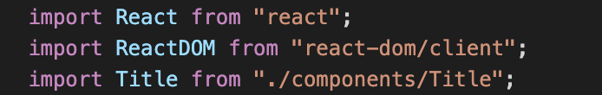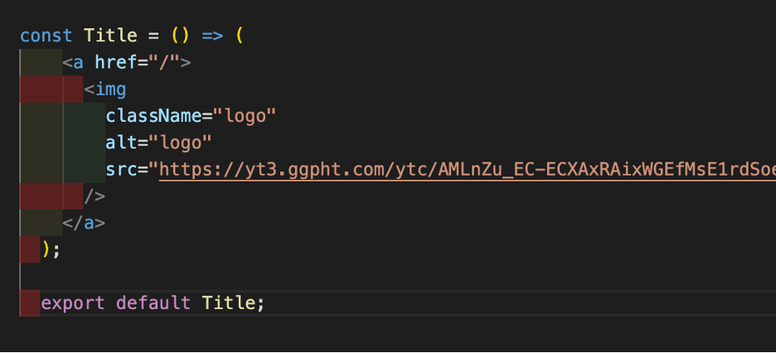

b) Named Import

It is used if multiple components is present in a file

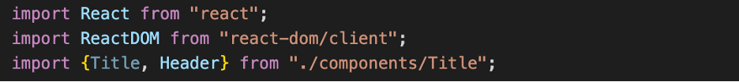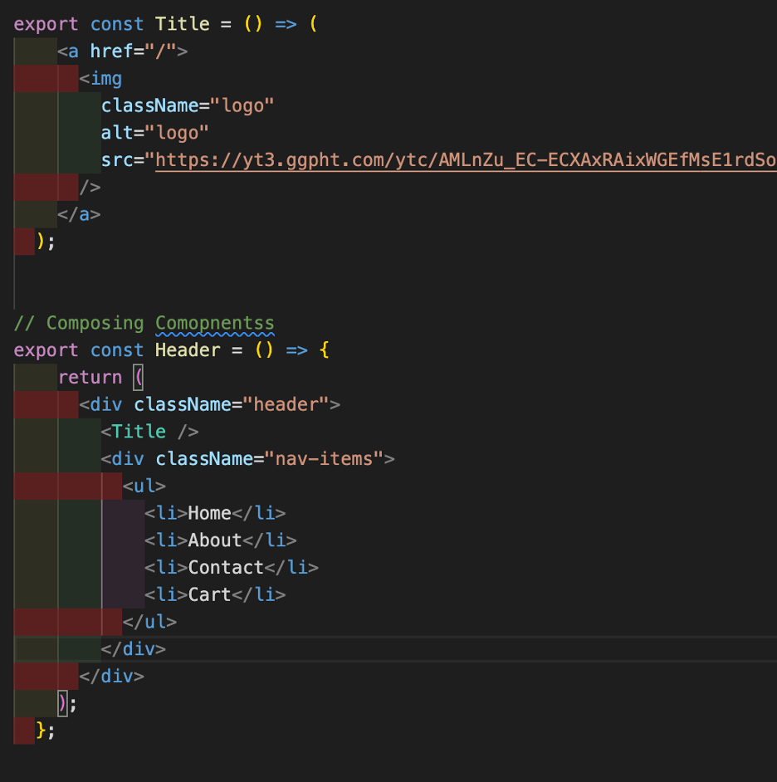

**4. What is config file used for ?**

Put all Hardcoded stuff in config file ◊ eg) CONSTANTS file

**5. What binding React uses ?**

React uses one-way data binding.

**6. State in React JS ?**

Every component in react maintains a state. We can put all variables into state. State can ve modified.

**7. Hooks in React JS ?**

Hooks are functions. Hooks are from React lib. Developed by fb developers

Use state returns an Array [search, setSearch]

UseState, UseEffect, useReducer Hook